# **ASSIGNMENT 1**

# **BOOKS AND BYTES**

Name : kavya T

Roll no: 20AD026

**1.Creating database for books and bytes:**

CREATE DATABASE BOOKSDB;  
USE BOOKSDB;  
CREATE TABLE BOOKS(  
BOOKNO INT PRIMARY KEY,  
TITLE VARCHAR(50),  
AUTHOR VARCHAR(75),  
PUBLICATION_YEAR INT,  
PRICE INT  
);  
INSERT INTO BOOKS VALUES(1,"SQL FOR BEGINNERS","SHANE BLACK",2003,2600);  
INSERT INTO BOOKS VALUES(2,"SQL STORYBOOK","WILLIAM SHAKESPHERE",1990,2800);  
INSERT INTO BOOKS VALUES(3,"T-SQL FUNDAMENTALS","ITZIK BEN-GAN",2002,1500);  
INSERT INTO BOOKS VALUES(4,"SQL PROGRAMMING","BEN CHAN",2016,384);  
INSERT INTO BOOKS VALUES(5,"HANDS ON SQL","ABISHEK CHOUDARY",2011,322);  
INSERT INTO BOOKS VALUES(6,"SQL PRACTICE PROBLEMS","SYLVIA MOESTL VASLIK",2013,2403);

**a. Retrieve all the books from the database**

SELECT*FROM BOOKS;

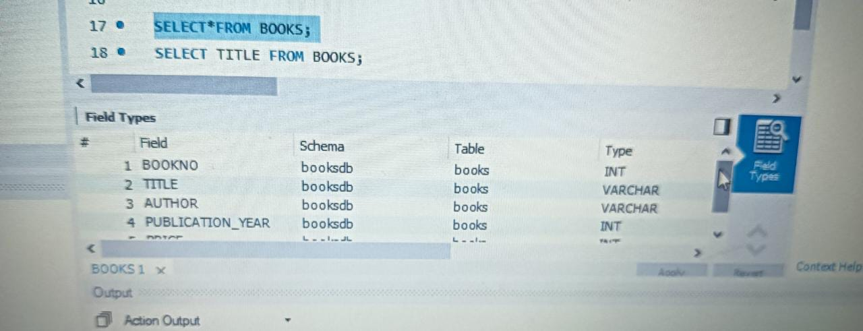

**b. Retrieve the details of a book based on its title.**

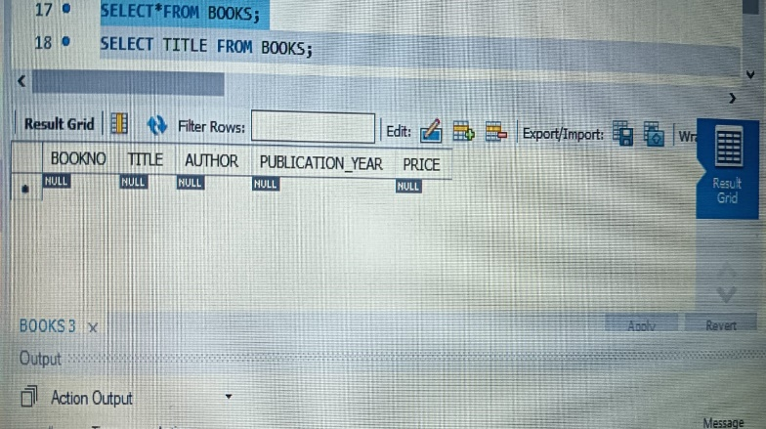

SELECT TITLE FROM BOOKS;

**c. Update the price of a book.**

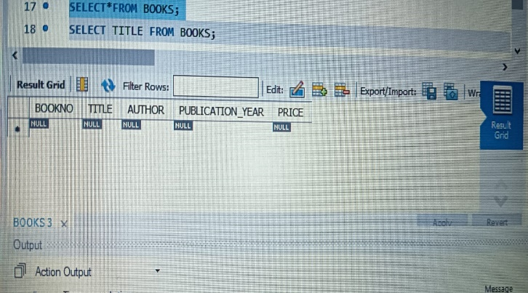

UPDATE BOOKS SET PRICE=3000 WHERE BOOKNO=1;

**d. Delete a book from the database based on its title**.

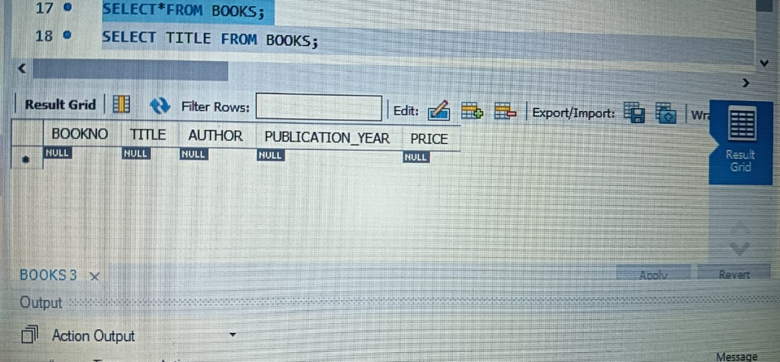

DELETE FROM BOOKS WHERE BOOKNO=5;